EPAM University Programs

DevOps external course

Module 4 Linux & Bash Essentials

TASK 4.6

*Mariia Markina*

1. User management. Here we suppose there are at least two users, namely, root and guest.   
(i) Create a new user user

groupadd user -creating new group named “user”

useradd -g user -s /bin/bash -d /home/user -m user – adding new user in a group “user”, setting a shell for logging in, and setting a home directory (and saying, that this directory should be created), setting name “user” for user.

passwd user – setting a password for user “user”.

id user – shows information about user and to which groups it belongs.

ls -ld /home/user – shows information about users home directory.

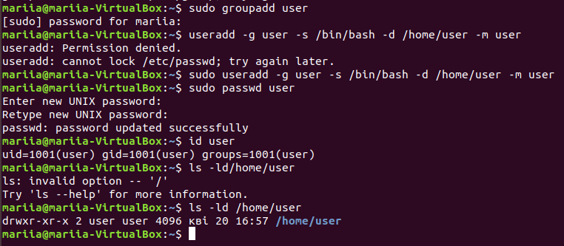

(ii) Log in to the system as “user” (hint use su).

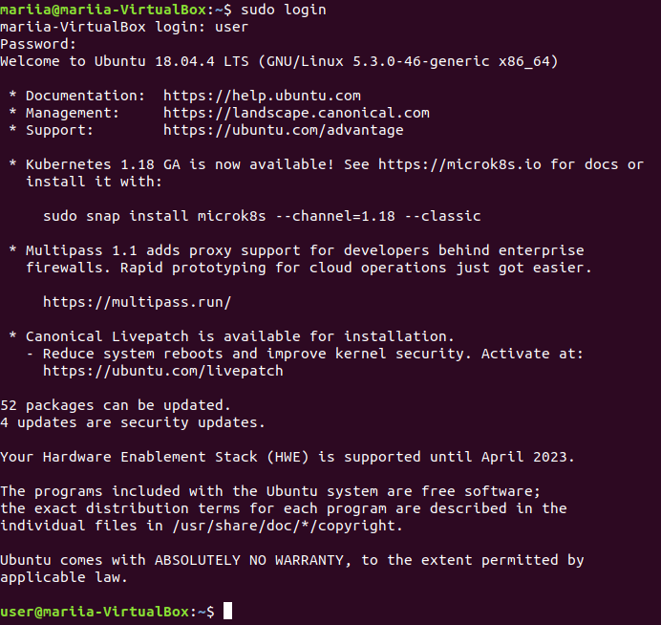

(ii) Edit /etc/passwd to prevent user user from logging in to the system.







2. Content of /etc/passwd and /etc/group.

(i) Look through /etc/passwd and /etc/group (hint: use less or cat).

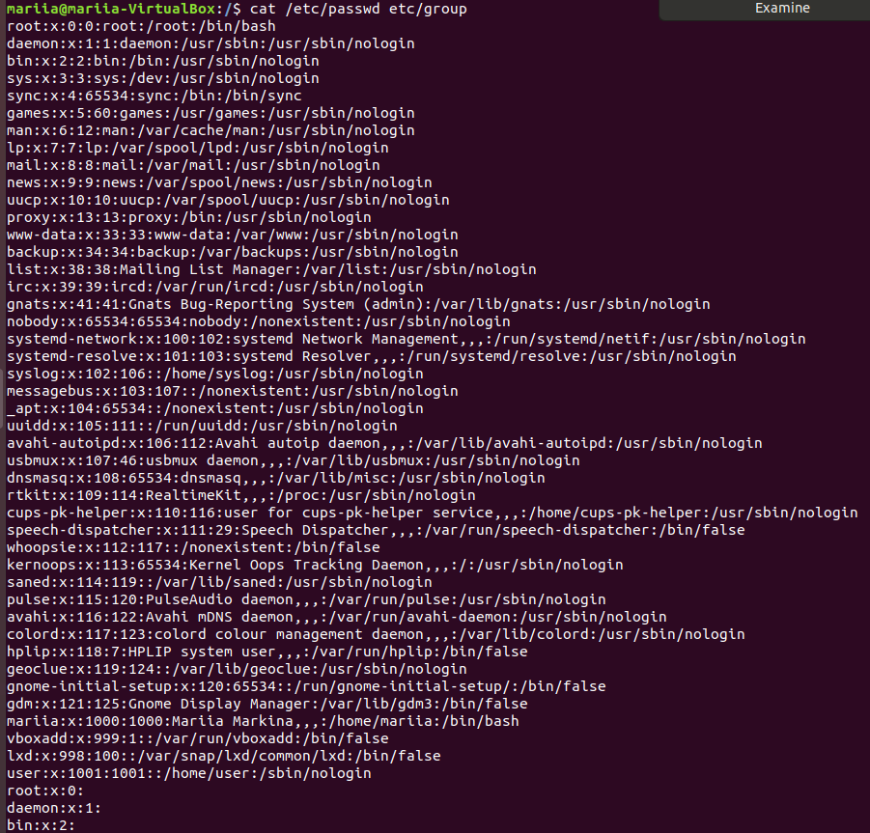

(ii) Get data from /etc/passwd and /etc/group about users: root, guest, user (hint: filter by grep).

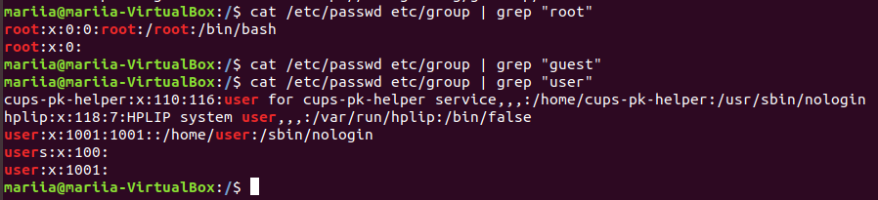

(iii)Parse /etc/passwd and /etc/group with cut.

cut -f1 -d: /etc/passwd – displays everything from file /etc/passwd, that comes before first “:” symbol.

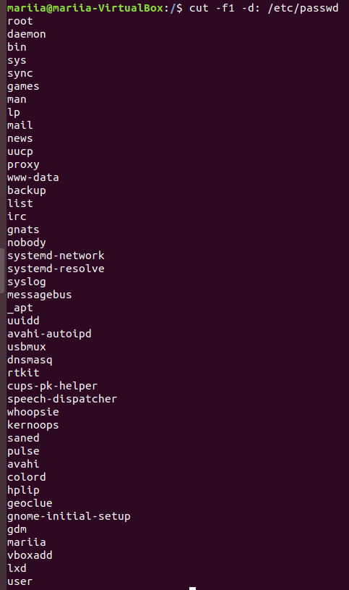

cut -f1,2 -d: /etc/passwd – displays everything from file /etc/passwd, that comes before second “:” symbol.

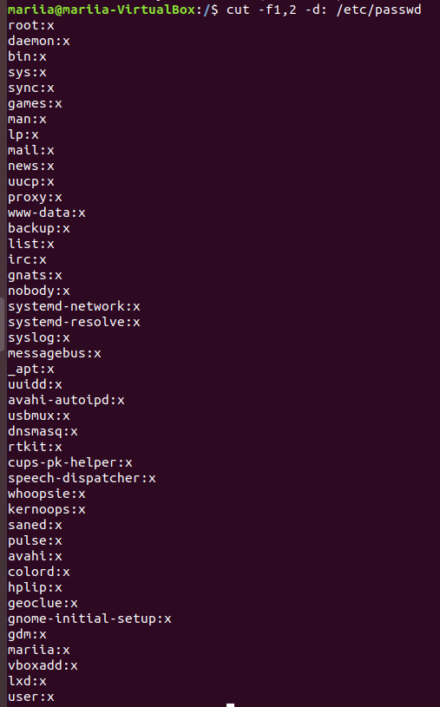

cut -f1,7 -d: /etc/passwd – displays first and seventh field between “:” symbol.

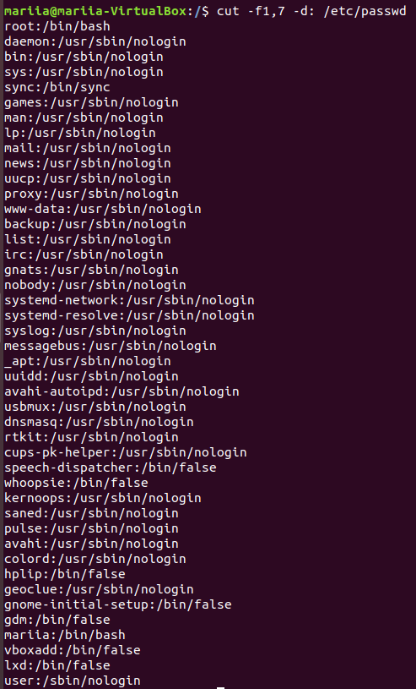

cut -f1 -d: /etc/group – displays everything from file /etc/group, that comes before first “:” symbol.

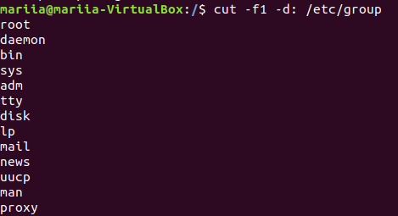

cut -f1,2 -d: /etc/group – displays first and second fields between “:” from file /etc/group

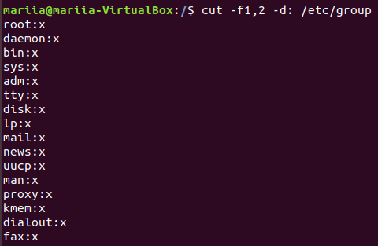

(iv) Try to call less on /etc/shadow and invoke

sudo less /etc/shadow

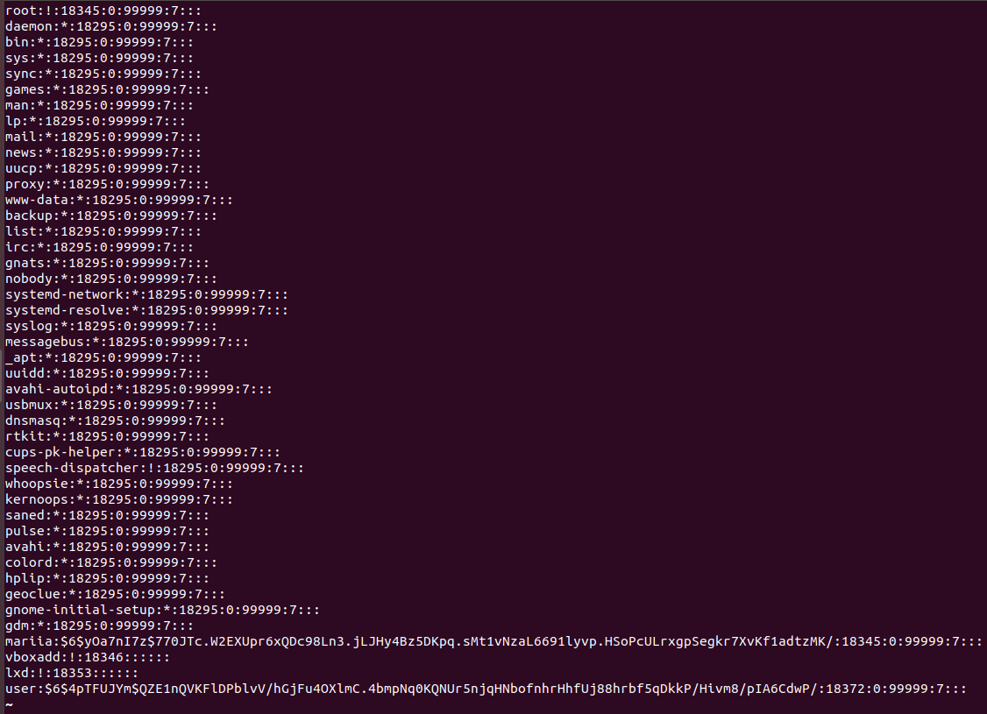

man -k shadow – searches information about shadow in manuals

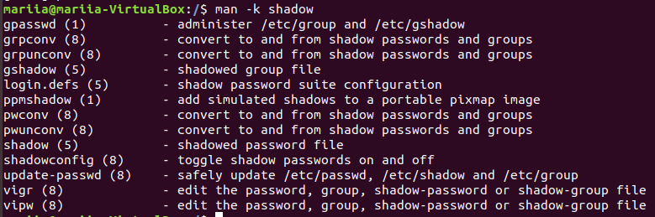

man 5 shadow – searches manual about shadow in fifth section (file formats and conversions)

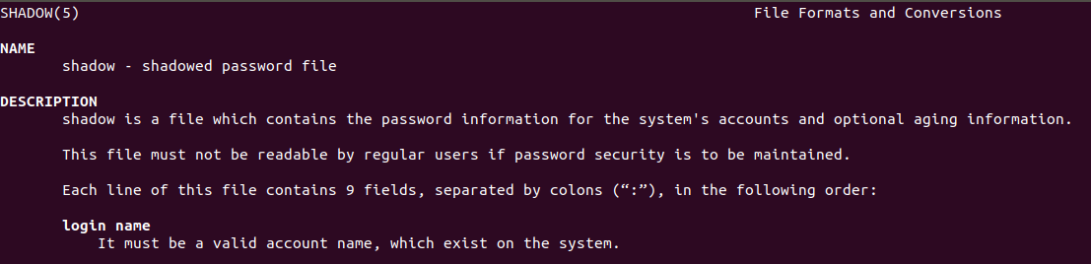

Analyze content of /etc/shadow based on what you’ve found in man 5 shadow.

Shadow contains information about passwords, dates when they are going to be expired, etc. First field between “:” shows login name, second – encrypted password, third – time since the last password change (days since Jan, 1st, 1970), then there is information about minimum and maximum age of the password as well as other information about aging, and reserved field.

3. Dealing with chmod.

(i) An executable script. Open your favorite editor and put these lines into a file

#!/bin/bash

echo “Drugs are bad MKAY?”

Give name “script.sh” to the script and call to

chmod +x script.sh

Then you are ready to execute the script:

./script.sh

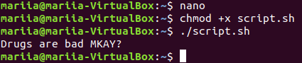

(ii) Suppose, you have logged in to the system as guest. Create directory “testDir” in the /tmp; put some file into testDir and prohibit user user from visiting this directory (i.e. “testDir”).

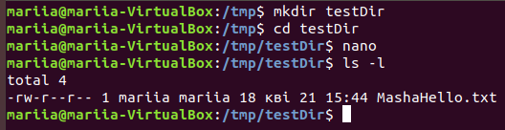





In this case only owner of the folder (mariia) has full access to it, no one else, including user, can`t do anything with this directory.

(iii) Test, if it possible to forbid an owner of some file to read to or write from this file.

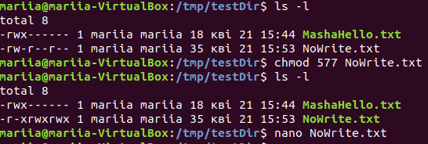

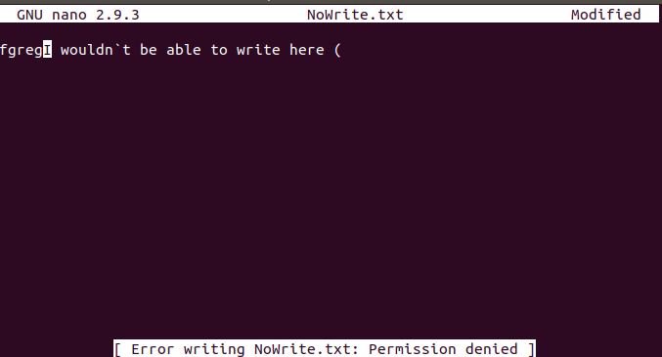

Yes, in this case I have forbidden to write in the file for its owner. Now, I can`t write there, however, I can save this file with the different name and write there. It is also possible to take away permissions to read and execute.